Creating Opportunities Through Clubs
  - Different interests and different routes into learning
Club | Learning purpose
Digital Dragons | AI understanding, creative content and responsible digital use
Brain Battle | Reasoning, problem solving, teamwork and resilience
Math Games Lab | Number sense, fluency, logic and mathematical communication
Chess | Strategy, planning, concentration and perspective-taking
Little CEOs | A pathway for entrepreneurial interests within the wider programme
Media and Public Speaking | Communication and opportunities for student voice
Sustainability and Mad Scientist | Further routes for curiosity and exploration

Actions
I developed club outlines, promotional materials and a registration and allocation approach. Programme updates included replacing podcast provision with Media Club and refining grade access and group capacities.

Impact
The programme broadens opportunities for students to explore interests and practise thinking and communication beyond formal lessons. Participation and learning outcomes need to be reviewed through club records and student work.

Evidence
Club descriptions, flyers, grade allocations and teacher assignment materials demonstrate the programme design. The online Fast Math invitation and parent comments show a further learning opportunity beyond school.
Reflection
A club’s value is shown through what students experience, create and learn. Clear expectations and equitable access matter as much as the range of activities offered.

Bringing Families Into Mathematics
  - MathFit, student leadership and shared learning

Actions
I organised the MathFit Family Challenge with Cuemath for children from KG to Grade 5 and their families. The free event model includes fluency, understanding, reasoning and application stations, with a personalised learning profile. Student leaders were asked to welcome families, guide participants and support activities.
Event element | Purpose
Four mathematics stations | Help families observe different aspects of mathematical thinking
Shared participation | Create opportunities for positive parent-child learning
Student leadership | Develop responsibility, communication and service
Personalised profile | Offer a basis for discussing strengths and next steps

Impact
The arrangements create an opportunity to connect families with the way children think mathematically. Attendance, feedback and learning outcomes require post-event records before a stronger impact statement can be made.

Evidence
Event invitations, bilingual parent communications, organiser materials, leadership arrangements and consent documentation show the coordination involved.

Reflection
Family engagement is strongest when parents leave with a clearer understanding of their child’s thinking and a practical way to support learning at home.

Family Light Lab Ramadan Through Math
  - A family event connecting mathematics, creativity and the Year of the Family

Actions
I organised Family Light Lab: Ramadan Through Math as a shared experience for KG and elementary students and their families. The event brought mathematical ideas into a meaningful celebration, with families working alongside children to design Ramadan decorations.
Explore shapes → Create patterns → Design together → Share the learning
A 45-minute classroom experience, planned across 28 classes, connecting mathematics with family collaboration.
Learning opportunity | How the activity supports it
Shapes and patterns | Children select, arrange and describe mathematical features in their designs
Mathematical communication | Children explain their choices while working with family members
Creativity and collaboration | Families develop a shared product through discussion and practical work
School community | Ramadan designs contribute to a shared corridor display

Impact
The event created a practical opportunity for families to participate in children’s learning and see mathematics used creatively. The shared decorations made family contributions visible within the school community. The planned class reach describes the event’s scope, rather than a verified attendance total.

Evidence
The event outline, family communication and the original portfolio’s record of students, parents and staff designing and celebrating Ramadan document the initiative. Children’s decorations and the corridor display provide examples of the shared activity. No separate event-feedback percentages have been supplied.

Reflection
Family events are most meaningful when children can explain the learning within the celebration. A shared product becomes stronger learning evidence when the child can describe the shapes, patterns and decisions used to create it.

Encouraging Challenge and Celebrating Achievement
  - Competitions, chess and purposeful recognition

Actions
I organised and supported internal mental and reasoning challenges, Speedy Math Quest, chess tournaments and participation in external mathematics competitions. Recognition includes certificates, trophies and classroom celebrations linked to effort and learning habits.

Impact
The original account reports students progressing to internal and external finals, two students qualifying for a Global Mental Math final and an individual second-place UCMAS international result. The later chess initiative records a capacity of 36 and eight finalists. Capacity is the number of available places, not confirmed attendance.

Evidence
Competition announcements, finalist records, celebration posts and photographs document participation and reported achievement. Entry and score records are needed to confirm the approximate qualification percentages described in the original account.

Learning beyond competition
The online Fast Math experience generated comments about useful tips and enjoyment. One parent also identified a mismatch with the advertised experience, showing the value of listening to critical feedback.
Reflection
Competition should create challenge and motivation while preserving access and confidence. Participation, strategy and perseverance deserve attention alongside winning.

Global Money Week
  - Connecting mathematics with financial decisions and responsible choices

Actions
I led or supported Global Money Week within our wider financial literacy work, connecting mathematics with budgeting, financial decisions and real-life application. This gives students a purposeful context for using number knowledge and explaining their choices.
Understand the choice → Use mathematics → Explain the decision → Reflect
Financial learning becomes meaningful when students can explain the reasoning behind a decision.

Curriculum connection
My wider financial literacy framework includes needs and wants, saving, budgeting, UAE currency, banking, careers, enterprise and responsible decisions. Global Money Week provides a focused opportunity to bring financial decision making into learning. These wider curriculum topics should not all be read as confirmed GMW activities.

Impact
The initiative is intended to develop the connection between mathematical knowledge and everyday choices. It creates opportunities for students to consider priorities, work within a budget and justify a decision. GMW-specific attendance, completed-task results and family feedback have not been supplied, so no participation or learning-gain figures are attributed to it.

Evidence
The departmental improvement portfolio identifies Global Money Week as a student opportunity focused on financial decisions, budgeting and application. The financial literacy framework and grade maps provide the curriculum context. Completed GMW task products, individual application checks and student reflections would demonstrate what learners achieved.

Reflection
Financial literacy is more than finding a correct total. The important learning is whether students can explain their priorities, recognise a constraint and make a reasoned choice. A short independent decision task offers a useful check of that learning.

Applying Mathematics to Real Situations
  - Projects, community experiences and meaningful contexts

Actions
I connected mathematics with Mathematics Awareness Week, Business Day, bake sales, Financial Literacy Day and project-based learning. Examples include sustainable UAE landmark models and AP application projects linked to UAE priorities, including an AI and driverless-taxi scenario.

Community contribution
The portfolio also records a visit to an old-age home, creating opportunities for collaboration, responsibility and social connection alongside classroom learning.

Impact
The activities provide purposeful contexts in which students can use mathematical models, calculations and explanations. Photographs and event records show participation; the quality of mathematical learning is demonstrated through the work students produce.

Evidence
Project outlines, linked artefacts, photographs, school communications and classroom work illustrate the breadth of application and community involvement.
Reflection
An engaging context should make the mathematics more meaningful. The strongest project evidence shows the problem, the student’s reasoning, feedback and an improved solution.

Listening to Parents
  - Using survey responses and testimony to understand experience
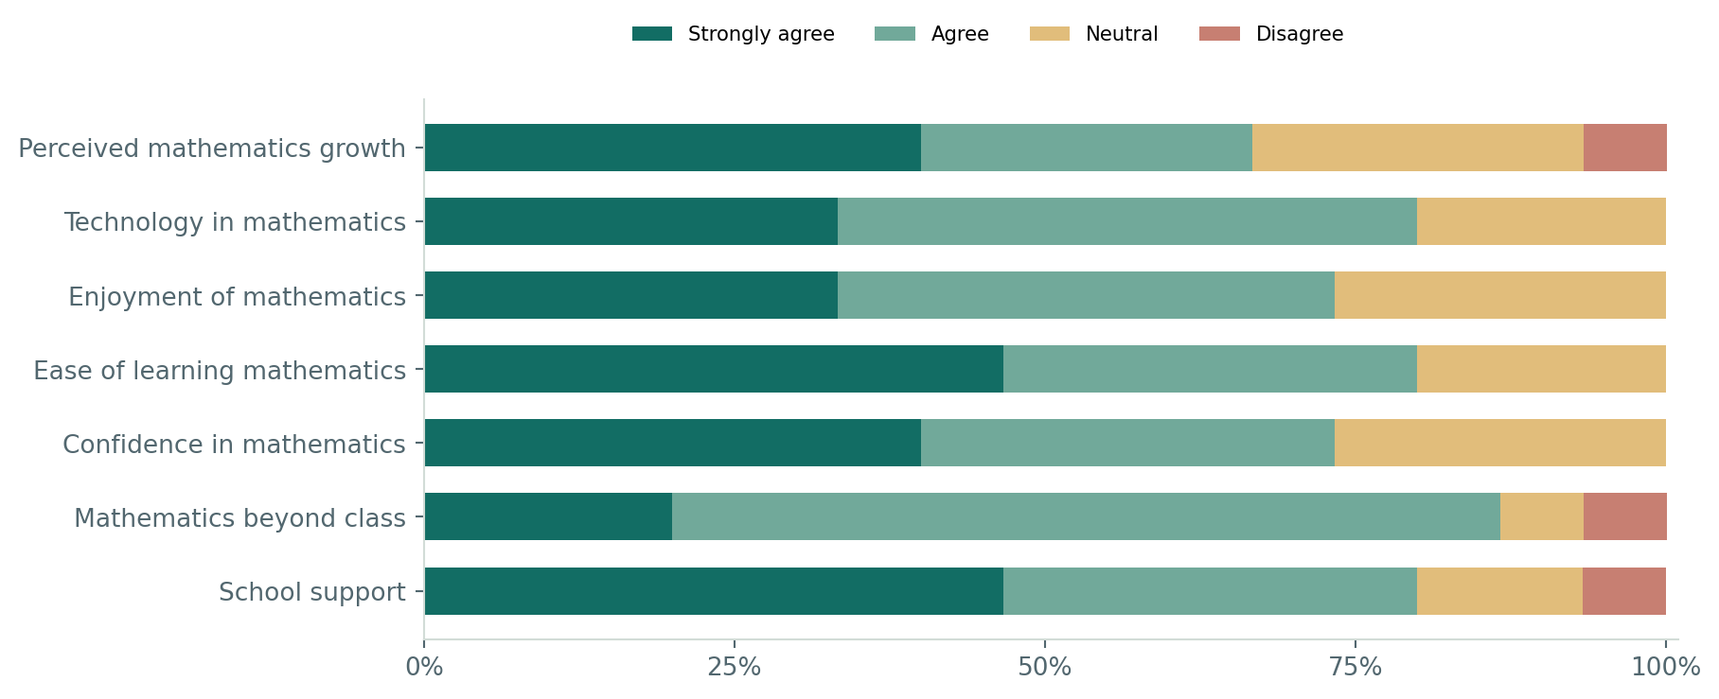
Parent feedback snapshot. Agreement combines “agree” and “strongly agree”. Response count, dates and response rate are not supplied.

Impact and analysis
Agreement is 86.7% for mathematics beyond class, 80% for technology, ease of learning and school support, 73.3% for enjoyment and confidence, and 66.7% for perceived growth. These are parents’ views rather than direct measures of attainment.

Evidence
Parent comments describe enjoyment of practical tasks, Boddle and games, increasing independence and willingness to explain thinking. Some also describe continuing difficulty. Home discussion is reported as often or very often by 53.3%, sometimes by 40% and never by 6.7%. Mathematics games form the largest single labelled activity-preference category at 26.7%; other categories combine activities.
Reflection
Families value the learning approach, while perceived growth is less positive than the other items. Clear targets and examples of progress can make home-school conversations more useful, especially for families whose children still find mathematics difficult.

Listening to Students
  - Support, confidence and the experience of challenging learning
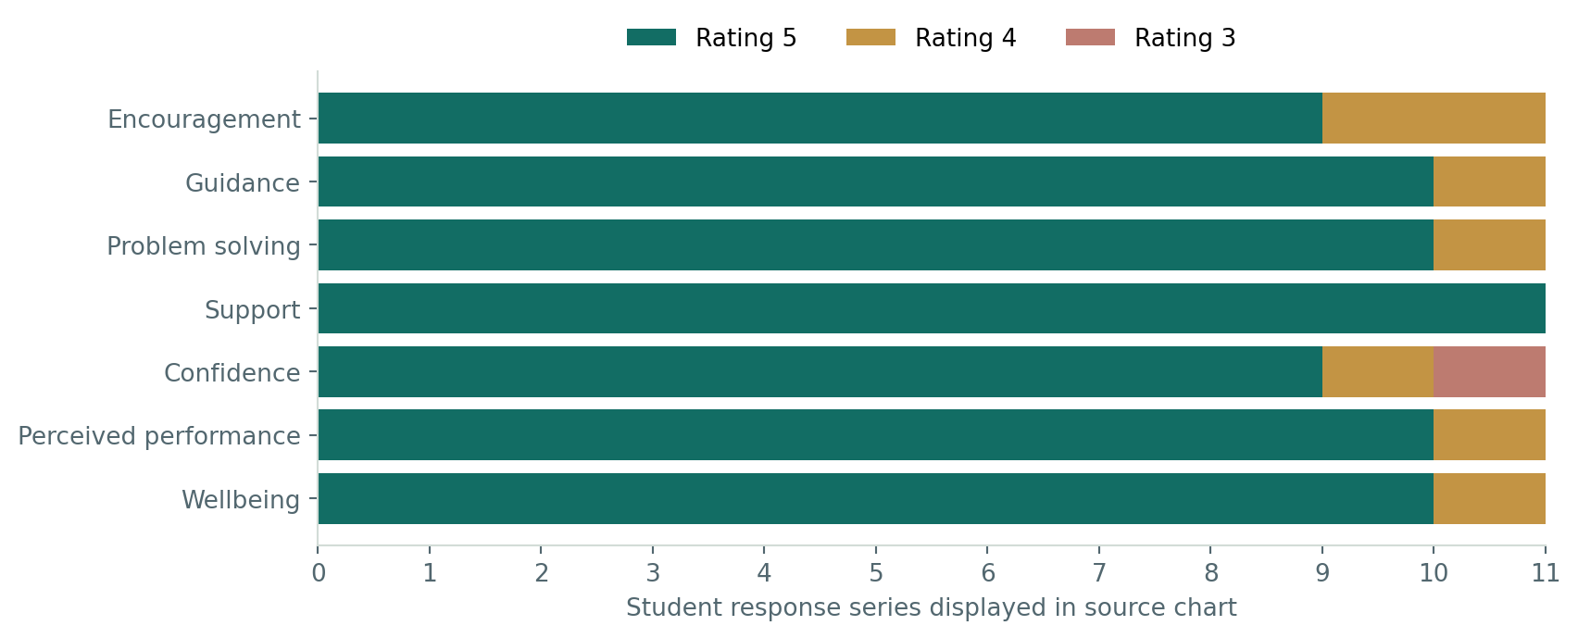
AP reflection snapshot. Eleven response series are shown anonymously. Numbers retain the source chart’s rating labels; scale wording is not supplied.

Impact and analysis
All displayed students rated support at 5. Guidance, problem solving, perceived performance and wellbeing were also highly rated. Confidence shows the widest spread, including one rating of 3. A rating about performance is a perception, not an examination score.

Evidence
Student testimonials describe clear explanations, encouragement, regular checkpoints and a safe space to ask questions. Later reflections describe increased independence and perseverance. Some acknowledge continuing difficulty or a disappointing examination result.
Reflection
Strong support does not mean every learner feels equally confident. Listening to individual concerns alongside independent work helps identify the next academic or pastoral response.

Teaching AP Calculus With Ambition and Care
  - Clear explanation, disciplined practice and official achievement evidence

Actions
I use structured explanations, visual representations and real-world applications to make abstract concepts accessible. Additional online teaching, targeted feedback and revision support address gaps while maintaining attention to confidence and wellbeing. I select College Board questions aligned with the syllabus, including calculator and non-calculator MCQ and FRQ components.
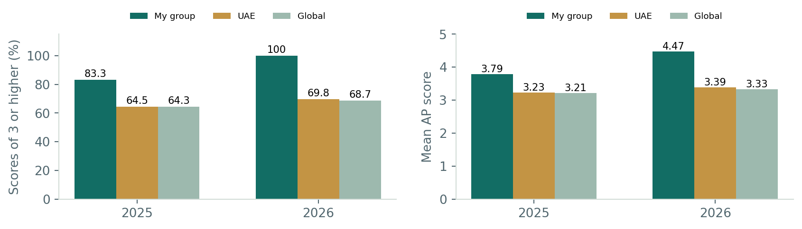

Impact
The official 2025 roster reports 20 of my 24 students scoring 3 or above, with a mean of 3.79. The 2026 planning report records all 15 students scoring 3 or above, with a mean of 4.47: eight scores of 5, six of 4 and one of 3. Both groups exceed the UAE and global comparisons shown in their respective reports.

Evidence
College Board reports identify my selected Calculus AB sections. The 2026 report covers Form 5; its UAE and global figures refer to that form, not the whole exam population. The two groups are different cohorts, so their comparison is descriptive. Student names and identifiers are excluded.

Reflection
All six free-response question means and the reported multiple-choice summary exceed the listed comparisons. Item analysis still identifies precise next steps: justification and individual low-scoring requirements need attention. Strong results should sharpen feedback, rather than end the review of learning.

Contributing Beyond My Classroom
  - Professional learning, shared practice and wider responsibility

Actions
I contribute through school improvement work, curriculum development and the sharing of teaching resources. My professional journey also includes Chartered College learning and my reported selection for the first Dubai Educators Council associated with KHDA.

Professional recognition
The selection account describes a portfolio and face-to-face evaluation process. The original portfolio also includes professional recognition associated with an education summit. These experiences sit alongside the daily work of supporting colleagues and students.

Impact
Wider involvement provides opportunities to exchange ideas, learn from other educators and contribute perspectives grounded in classroom practice. The educational value lies in how that learning informs decisions and supports others.

Evidence
Professional learning records, shared presentations, recognition materials and appointment documentation provide the evidence for these aspects of my journey. Formal titles and selection details should follow the relevant appointment records.
Reflection
My main professional direction remains instructional coaching. Mathematics gives depth to my practice; collaboration, reflection and attention to learners make that experience useful across teaching contexts.

Continuing My Professional Journey
  - Connecting actions, evidence and reflection
Across my work, a consistent purpose connects coaching, curriculum, assessment and wider initiatives: helping teachers make informed choices and helping students access learning, develop confidence and think independently.
Professional commitment | What it means in my work
Develop people | Create supportive opportunities to plan, practise and reflect
Design for progression | Connect learning with prerequisites and future expectations
Listen to learners and families | Use feedback to understand experience and identify concerns
Use evidence responsibly | Recognise improvement while investigating what still needs attention
Build sustainable practice | Connect initiatives with clear purposes and practical follow-up

Reflection
The evidence shows a journey of creating opportunities, responding to needs and learning with colleagues. It also identifies the next step: making the link between an action and the change in learning more visible through focused follow-up.
I want my contribution to be recognised through the quality of the support I provide, the professional growth of colleagues and the learning experiences available to students.
HEBA SALEH

