Using Assessment to Improve Teaching
  - Internal progress and attainment as evidence for action
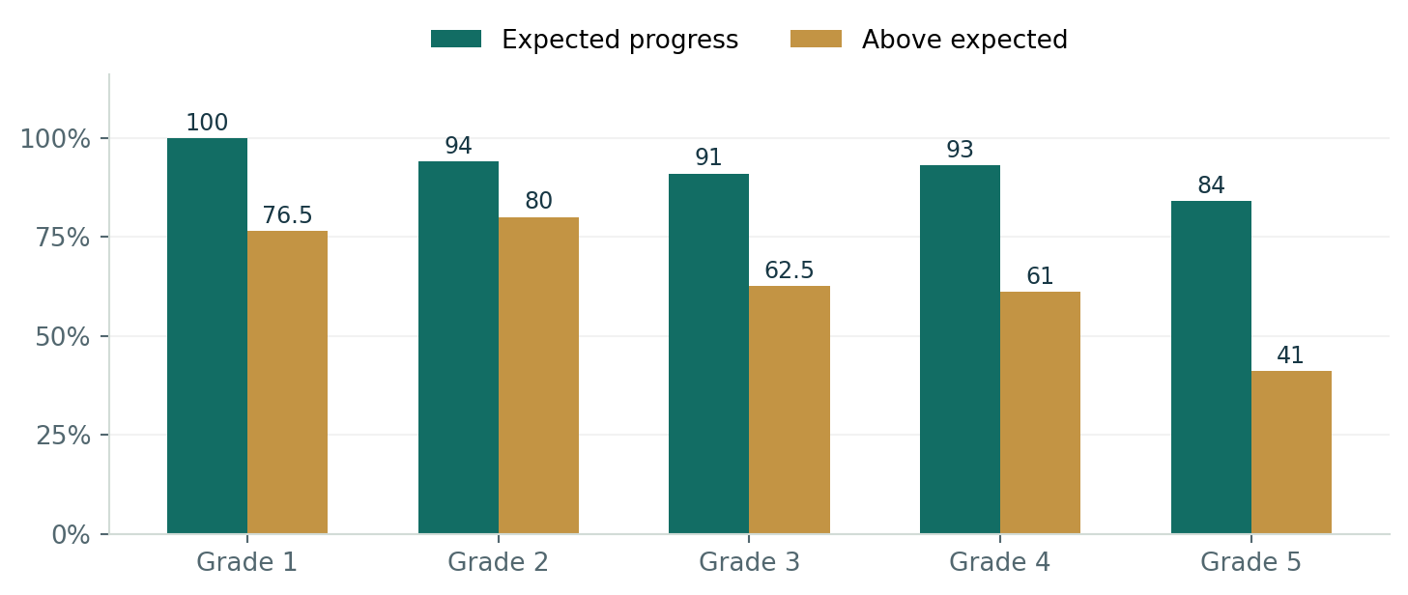
Internal assessment snapshot. Categories retain the wording in the assessment summary and may overlap.

Actions
I analyse assessment information alongside student work and lesson observations. I use class profiles, formative checks, reteach provision and weekly review to help teachers identify gaps and choose the next response.

Impact and analysis
The elementary summary reports 92.4% expected progress and 64.2% above expected progress. Grade 5 has the lowest proportions in this snapshot, making it a clear priority for reviewing prerequisite knowledge and support. Internal attainment is reported as 82.1% at a score of 67% or above and 61.8% at 77% or above.

Evidence
The internal assessment summary, tracking materials and intervention plans connect attainment information with instructional priorities. These are school outcomes reflecting the work of learners, teachers and leaders.

Reflection
A positive overall result can hide a learning need within a grade or group. The next check is whether the identified gap improves after targeted teaching.

Reading External Benchmarks With Care
  - A wider perspective on progress, attainment and language needs
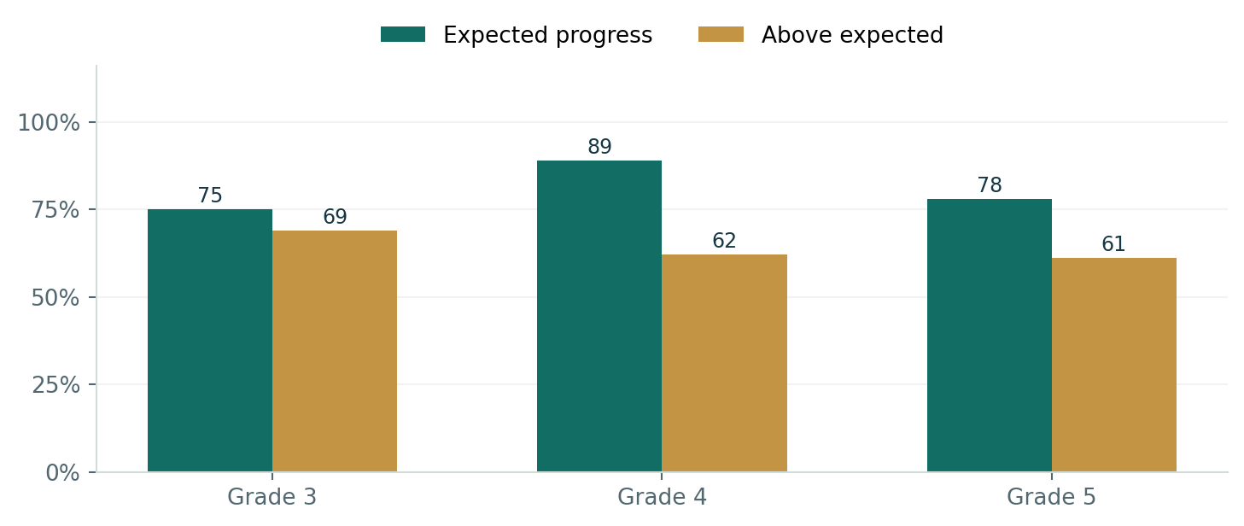
External progress snapshot. Percentages describe the assessment summary, rather than the progress of every individual learner.

Actions
I draw on external benchmarks, including MAP, TIMSS and NGRT, as well as internal evidence. Mathematical vocabulary, journals, storytelling and precise notation support language access. Different measures are used for the questions they can answer.

Impact and analysis
The external summary reports 81% expected progress and 64% above expected. Its attainment summary reports 85% at or above the 41st percentile and 72% at or above the 61st percentile. Grade 4 is strongest at both attainment thresholds.

Evidence
External assessment tables, NGRT trends and planning resources provide a second view of learning. The NGRT summary reports positive changes across its SAS thresholds; the calculation basis needs confirming before those figures are compared directly.
Reflection
External results are most useful when they inform classroom inquiry. Differences between measures should lead to a closer look at the learner, the task and the assessment conditions.

Understanding School Improvement and TIMSS
  - Recognising progress while keeping the comparison accurate
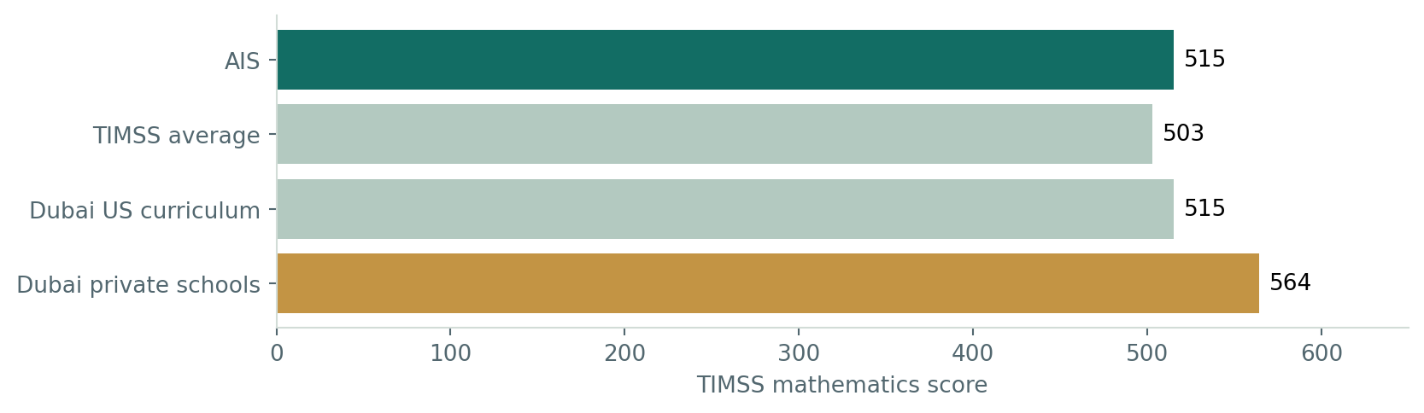

Actions
My portfolio connects assessment review, curriculum support and teacher development with the school’s mathematics improvement journey. Inspection extracts record improvement in progress and attainment, while TIMSS provides an external benchmark.

Impact and analysis
The school’s TIMSS score increased by 63 points between the two most recent cycles shown in the evidence. The score of 515 is above the displayed TIMSS average of 503, matches the Dubai US-curriculum figure and is below the Dubai private-school figure of 564.

Evidence
Inspection extracts, the school’s TIMSS trend and the content and cognitive-domain chart provide external perspectives. The domain chart shows a shift towards intermediate performance bands and away from the lowest bands.
Reflection
The evidence recognises school improvement while identifying further ambition. It reflects collective effort and different student cohorts; it should be read alongside the contribution and classroom evidence described throughout this portfolio.

Making Progress Visible Through Progress NEXT
  - A shared process for identifying needs and following up
Identify → Respond → Check → Review
A learning concern becomes useful when it leads to a teaching decision and a follow-up check.

Actions
I developed a weekly dashboard approach bringing classroom and whole-section information together. Progress NEXT covers understanding, fluency, vocabulary, reasoning, communication and learners at risk, with a documented intended reach of 28 classes and approximately 900 learners.
Teacher view | Leadership view
Identify misconceptions and learning priorities | Recognise patterns across classes and grades
Plan reteaching, guided practice or extension | Focus coaching and allocate support
Review independent learning after support | Follow up intervention and implementation

Impact
The system is designed to make learning needs and follow-up clearer, support focused professional discussions and connect curriculum expectations with classroom evidence.

Evidence
Dashboard development records and the documented reporting structure show the system’s purpose. Dated extracts linked to teacher actions and independent rechecks are needed to demonstrate its effect on learning.

Reflection
The value of a dashboard lies in the response it supports. A smaller amount of useful information can be more effective than a large amount of data without follow-up.

Building Fluency Through Practice and Feedback
  - Classroom routines, home practice and Boddle

Actions
I introduced a Mental Math and Fluency Notebook, dedicated Friday Fluency sessions and digital home practice. Boddle offers another route to practice, with learner reports helping identify skills requiring attention. AFL, AOL and Plickers support timely checks in lessons.

Impact
Parents and teachers describe greater engagement and willingness to practise. The platform examples show how practice, standards and learning gaps can be made visible. Student-attitude summaries also report enjoyment of mathematics and clear teacher explanations.

Evidence
Fluency materials, homework expectations, Boddle certificates, learner traces, class examples, standards reports and learning-gap screens show the provision and monitoring process.
Evidence | What it helps me understand
Practice records | Whether students are engaging with the assigned learning
Standards and gap reports | Which skills need a teaching response
Independent classroom work | Whether learning transfers beyond the digital platform

Reflection
Practice should strengthen understanding and useful strategies. A platform result becomes more meaningful when students can demonstrate the same learning independently away from the app.

Creating MathBoost Journey
  - A structured route towards independent learning
20 courses × approximately 30 minutes
Explore → Learn → Scenarios → Challenge → Evaluate → Reflection

Actions
I developed MathBoost Journey for Grades 3–5, combining mathematical vocabulary, scenarios, model answers, corrections and reflection. Students can return with a personal journey code, save their progress, collect badges and receive a transcript on completion.

Leadership and family follow up
The recorded dashboard includes participation and completion indicators, course information, current learning stages and a printable overview. The parent rollout encourages one or two courses each week so the journey is manageable alongside classroom learning.

Impact
The pathway is designed to make independent study more structured, encourage students to review mistakes and give leaders a clearer view of participation. Completion and attainment outcomes have not yet been established in the evidence available.

Evidence
Hub development records, the course structure, badge and transcript design, and leadership dashboard features demonstrate the initiative I created.
Reflection
Completion is a useful starting point. The more important question is whether students can explain what they learned and apply it to an unfamiliar problem.

Recognising Learning Through Math Stars
  - Making effort, responsibility and participation visible

Actions
I developed the Math Stars appreciation wall to recognise homework and classwork through a shared weekly process. Criteria include HMH homework, Boddle assignments, completed activities, notebook care, participation, following instructions and supporting peers.
Recognise → Submit → Review → Celebrate
Teacher submission and leadership follow-up connect classroom recognition with families.

Impact
The initiative is designed to strengthen learning habits, broaden recognition and keep families connected with classroom effort. The developed workflow allows teachers to save, submit, recall and update their wall.

Evidence
The teacher process, class and week views, leadership submission overview and parent-facing wall demonstrate the system developed. Follow-up should examine actual participation and the reach of recognition across learner groups.

Reflection
Recognition should encourage improvement and belonging. Its quality depends on clear criteria and whether different learners have a fair opportunity to be recognised.

